# DOCUMENT 1: CANDIDATURE PROPOSAL FORM

To be completed and signed by the candidate and the NOC.

Personal information

|  |  |  |
| --- | --- | --- |
| Family name ofthe candidate: | | Given name ofthe candidate: |
| Full name to be used in publications: | | |
| Gender Male Female  口Other  Date ofbirth (DD/MM/YYYY): | Non-binary | National Olympic Committee: |
| Mothertongue: | | Other language(s) spoken and level*:  *French and/or English mandatory |
| Candidate email: | | Candidate phone number: |
| Candidate t-shirtsize: XS口 M口 L口 XL口 XXL口 | | |

Sport information

|  |  |
| --- | --- |
| Sport: | Discipline/ event: |
| Did the candidate compete in the Olympic Winter Games Beijing 2022?  口YES  口NO | Has the candidate qualified forthe Olympic Winter Games Milano Cortina 2026?  口Qualified  口Hoping to qualify  口Nothoping to qualify/ retired |

Athletes' Commission information

|  |  |  |
| --- | --- | --- |
| Do you have an NOC Athletes' Commission?  █YES  口NO | Is the candidate a member of your NOC Athletes' Commission?  口YES – How long have they been a member?  口NO | Is the candidate a member of their IF Athletes' Commission?  口YES - How long have they  been a member?  口NO |

Please ensure that you submit and, where relevant, sign, all the above-listed documents. Please note that only complete submissions will be considered.

By signing this form, the candidate and the National Olympic Committee confirm that they have read and understood:

* the present Privacy Notice
* the IOC Athletes ‘Commission Regulations and the IOC Athletes ‘Commission Election Procedure, and that they accept the content of these Regulations and Election Procedure.

By signing this form, the candidate and the National Olympic Committee acknowledge that the information contained in the candidate's answers to the questions mentioned at the end ofDocument3 may be used in the IOC Athletes ‘Commission Election Manual and other promotional material if they are declared eligible by the IOC Executive Board.

Furthermore, by signing this form, the candidate and the National Olympic Committee confirm that all

information that is provided as part of their submission is correct.

Date and place:.........................................................................................................................................................

Names and Signatures:

Candidate:.................................................................................................................................................................

NOC President Secretary General (or other authorized representative of the NOC):

Chair of the NOC Athletes'Commission:.............................................................................................................

# DOCUMENT 2: IOC ATHLETES'COMMISSIONELECTION RELEASE FORM

(to be completed and signed by the "Candidate")

Candidate Name: Address:

Executed in: Date: Signature:

As part of my candidate for the IOC Athletes ‘Commission election on the occasion of the Olympic Winter Games Milano Cortina 2026, I agree to be photographed and/or filmed and to contribute content(e.g. Candidature file color photos), and any participation by me in the production of content(the "Contribution"), as well as to permit the production of content (the "Content")for the IOC & Affiliates (as defined below). I agree and confirm that the Contribution and Content(jointly the "Material") can be distributed worldwide in any media, formator technology, now known or later devised, without any restriction of time or territory, through media platforms operated directly or indirectly by the IOC & Affiliates or third parties such as broadcasters, social media networks, International Federations, National Olympic Committees, Organizing Committees for the Olympic Games or the Youth Olympic Games, and other partners. Any such Material is or will be consistent with the Fundamental Principles of Olympism.

The IOC & Affiliates may sub-license and/or assign the Material and/or the rights thereto, for the purpose of promoting the IOC & Affiliates and/or distributing and promoting their content(including within the context of commercial activities).

I confirm that the Contribution is or will be free from any encumbrances that could preventor limit its use or the use of the Content in accordance with the terms of this Release Form and that it will not defame or infringe the rights of any person or organization. Likewise, I acknowledge that the Material will not be used in a manner that creates a direct personal commercial endorsement by me of a particular productor service without my consent. I understand that the Contribution is being made without payment and that the IOC & Affiliates have no obligation to use it.

I agree and confirm that:(a)the IOC & Affiliates may use the Material in whole or in part, and that it may be edited, adapted, translated and/or combined with other materials; (b) no claim or demand against the IOC & Affiliates, or any third parties authorized by the IOC & Affiliates, that relates to use of the Material shall be made; and (c) no moral rights on the Contribution shall be exercised against the IOC & Affiliates or any third parties authorized by the IOC & Affiliates. Insofar as the Contribution, as well as the further information about me contained in this Release Form, constitute protected personal data under applicable laws, I understand that the use of the Contribution as authorized herein requires, and that the IOC has legitimate interests to conduct, the processing (including, without limitation, the collection, storage, conservation, consultation, adaptation, editing, distribution via all media, broadcasting ,transmitting, making available, tagging, identification and destruction) of such personal information by the IOC & Affiliates, as well as their authorized service providers acting on their behalf and third parties authorized by them, in Switzerland and in any other place, including outside the European Union. For any query related to such use of my personal information, I can contact the IOC through the IOC's dedicated portal as indicated in the IOC's privacy policy.

The IOC is an international non-governmental not-for-profit organization, in the form of an association with the status of a legal person, recognized by the Swiss Federal Council. The object of the IOC, and the entities or companies now existing or to be created, owned or directly or indirectly controlled by the IOC (such as, without limitation, the Olympic Foundation for Culture and Heritage, IOC Television & Marketing Services S.A., Olympic Channel Services S.A. and Olympic Broadcasting Services S.A.) and their respective affiliates (the "IOC & Affiliates"), is to fulfil their missions, roles and responsibilities in accordance with the Olympic Charter and to promote the Olympic Movement and Olympism throughout the world. References to the IOC & Affiliates includes their successors, employees, members, affiliates, assignees, licensees and third parties authorized by them. This Release Form constitutes a binding agreement to be interpreted in accordance with the laws of Switzerland. Disputes arising from it shall be finally settled, to the exclusion of the ordinary courts, in accordance with the Statutes and Regulations of the Court of Arbitration for Sport, with the seat of arbitration in Lausanne, Switzerland, and English as the language.

# DOCUMENT 3: CANDIDATE BIOGRAPHY AND STATEMENT

## BIOGRAPHY

(To be completed by the candidate in English or French.)

|  |  |  |  |
| --- | --- | --- | --- |
|  | Year | Sport/Discipline/Event | Results/ranking |
| Olympic Games |  |  |  |
| World Championships |  |  |  |
| World Cups |  |  |  |

SPORTS CAREER - MAIN RESULTS*

*for disciplines on the Olympic programme PROFESSIONAL CAREER

List in chronological order in the grouping below.

|  |  |
| --- | --- |
| Education/studies | Type of qualification - subject- name of university - year |
| Professional activities | Job title - name of company - dates in this position |
| Functions in the field of sports administration (AC, NOC, IF, NF,  etc.) | Job title - name of organization - dates in this position |
| Membership of other associations | List in chronological order the positions held in associations that are not linked to the world of sport |

|  |  |
| --- | --- |
| Awards and distinctions | List in chronological order any awards and distinctions received |
| Publications | List the works you have authored, either by title or by stating the subject addressed |
| Other activities | List in chronological order the role and positions held in citizen movements that are not related  to the world of sport, plus any other charity initiative |

## STATEMENT

(to be written by the candidate in English or French)

Please explain why you wish to become a member of the IOC athletes’ Commission and a member of the IOC. The statement must be typed in the box below and should not exceed 1,100 characters (including spaces). The message should be addressed to the athletes, encouraging them to vote for you.

In addition, please answer the questions below candidate in English or French. Please be aware that these answers may be used in the IOC athletes’ Commission Election Manual and/or other promotional material for the election (200 characters max. for each question, including spaces):

1. Why are you standing as a candidate for the IOC AC?
2. What experience do you have that you would bring to the IOC AC?
3. Why should your fellow athletes vote for you?
4. What is the biggest challenge you have faced as an athlete?
5. How did you become involved in sport?
6. How has sport had an impact on your life?
7. What would be your top three priorities if you were elected?
8. Describe your personality in three words:
9. What are you passionate about?
10. Why is the athletes ‘voice important to you?

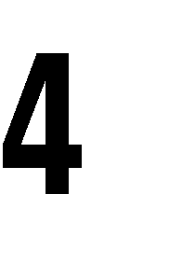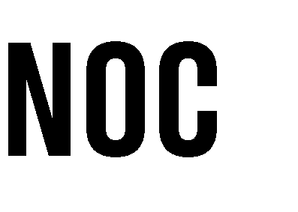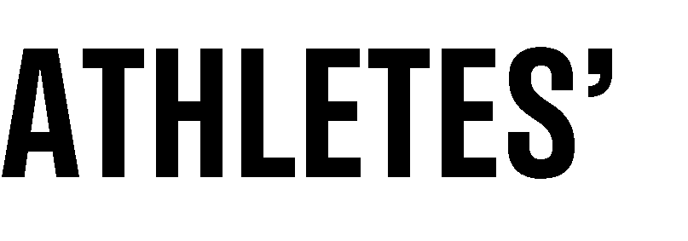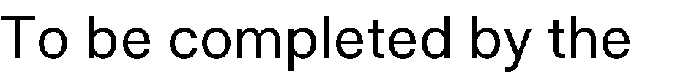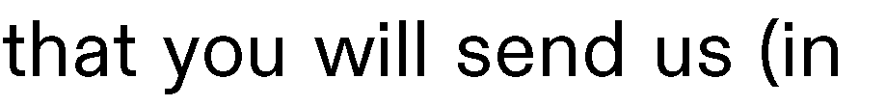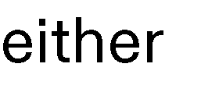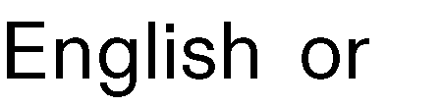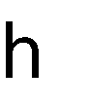

-

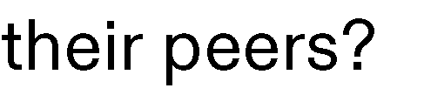

-

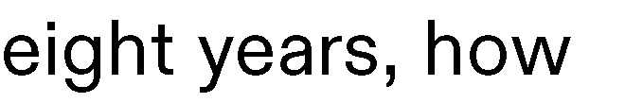

-

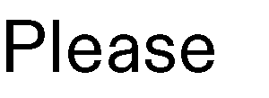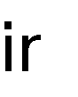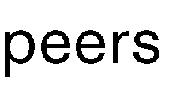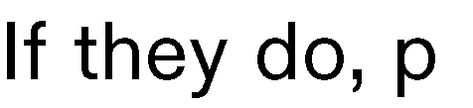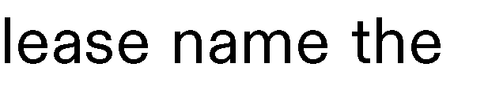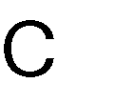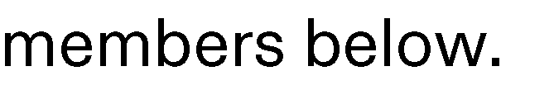

-

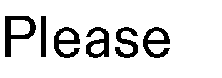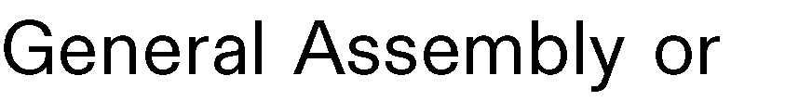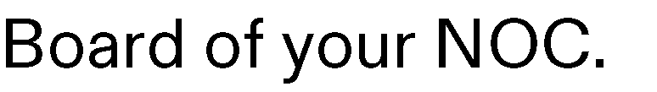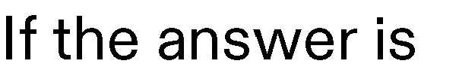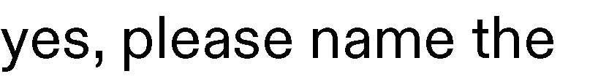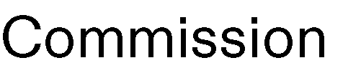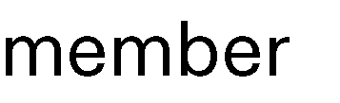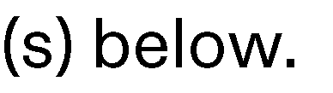

-



-





-



-

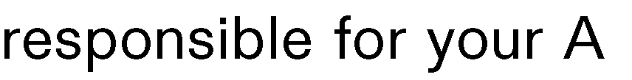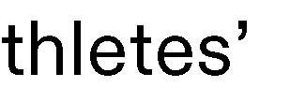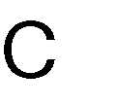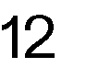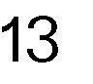

# DOCUMENT 5: CANDIDATE PHOTO REQUIREMENTS

The candidature file must contain the following color photos in high resolution electronic format and which must be compliant with the photo requirements detailed below:

* + 1x recent color portrait photo of the candidate(from head to chest)with a plain background;
  + 4x action color photos of the candidate practicing their sport(two in landscape format and two in portrait format);

These photos will be used to present the candidate in the Election Manual and other promotional items related to the election. Therefore, they need to be both of good quality and in very high resolution (4,000x6,000 pixels @ 300 dpi).

Action Photo Requirements

The action shots must comply with the Bye-law to Rule 50 of the Olympic Charter. To ensure that the action shot photos are Rule 50-compliant,the IOC recommends that the photo is one taken during past Olympic Games.

Paragraph 1 of the Bye-law to Rule 50 states: "No form of publicity or propaganda, commercial or otherwise, may appear on persons, on sportswear, accessories or, more generally, on any article of clothing or equipment whatsoever worn or used by all competitors, team officials, other team personnel and all other participants in the Olympic Games, except for the identification - as defined in paragraph 8 below - of the manufacturer of the article or equipment concerned, provided that such identification shall not be marked conspicuously for advertising purposes."

According to paragraph 8 of the Bye-law, "the word' identification ‘means the normal display of the name, designation, trademark, logo or any other distinctive sign of the manufacturer of the item, appearing not more than once per item."

Further details on Rule 50 can be found on NOCnet in the "[Guidelines re9.filQloA_ugthorised Identifications](https://ioccp.sharepoint.com/sites/noc_gmp/SitePages/Milano-Cortina-2026.aspx)". Portrait photo requirements

The photo should be taken with a plain background and in a well-lit indoor setting. The photo should include at least the head and shoulders of the candidate. Ensure that the visible clothing complies with the Bye-law to Rule 50 of the Olympic Charter.

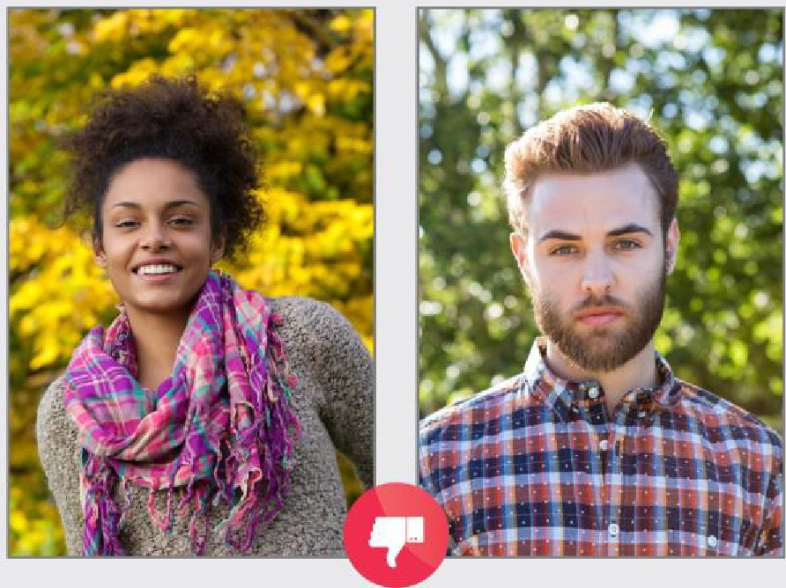

IOC athletes’ Commission Election - Olympic Winter Games Milano Cortina 2026 – Candidature File 13/13